15. Plot of Various Projections of a Sphere
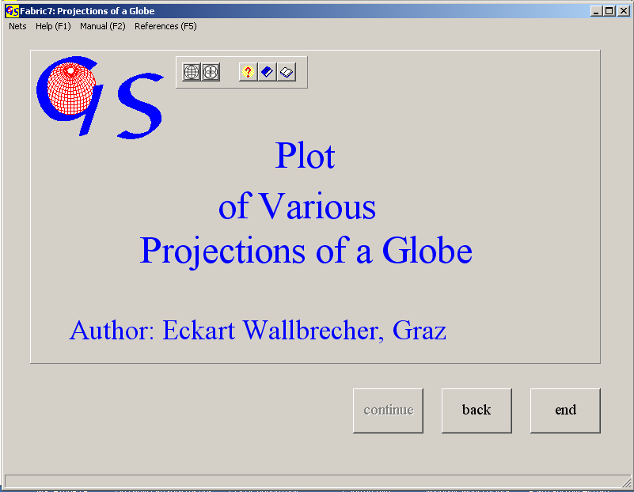
Fig. 1

This program (Fig. 1) plots either nets in various projections or counting grids, also in various projections, which may be used to produce contour line diagrams (Fig. 2).

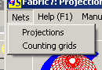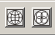
Fig.2

1. Nets in various Projections:

The following projections of a globe can be plotted:

1. a Schmidt net
2. a Wulff net
3. an orthographic net
4. a Kavraiskii net

Fig 3 shows the graphis form for Lambert’s projection (Schmidt net). With the menus "Hemisphere" and “Projection“ the type of projection can be changed. In the input field on the right side the distance between great and small circle can be chosen. It should be a divisor of 90. The angle of tilt sets the tilt angle of the north-south-axes.

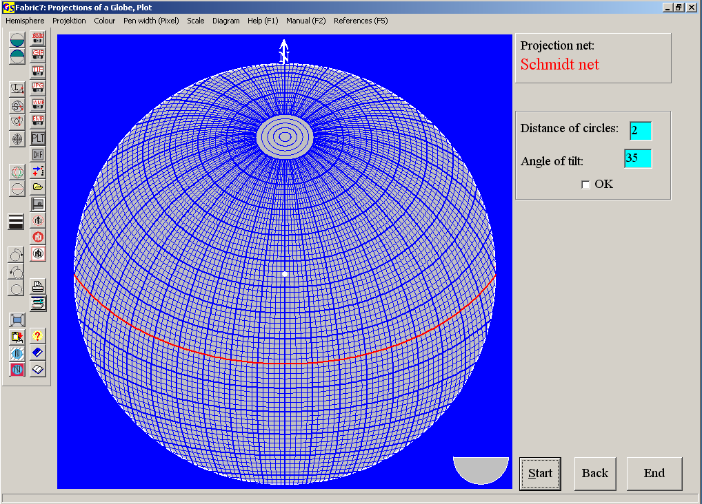
Fig. 3

Fig 4, 5, and 6 show the nets for stereographic (Wulff net), orthographic, and the Kavraiskii projection.
These projection can be used for teaching. Tilted nets can help to carry out rotations about non horizontal axes, or to draw small circles. The orthographic net can also be used to construct block diagrams.
Another application is especially for the Wulff and Schmidt net is the overlay with the plots of programs 3, 4, 5, 8 to 13. This can be done by saving the net on the clipboard (menu „Graphic“) and pasting to the graphic form of one of these programs.
A scale can be added to the nets (Fig. 7).
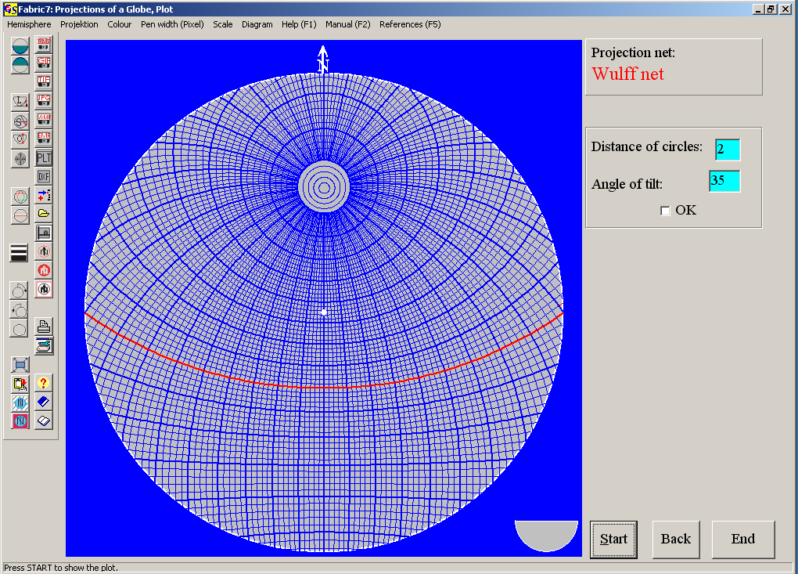
Fig. 4

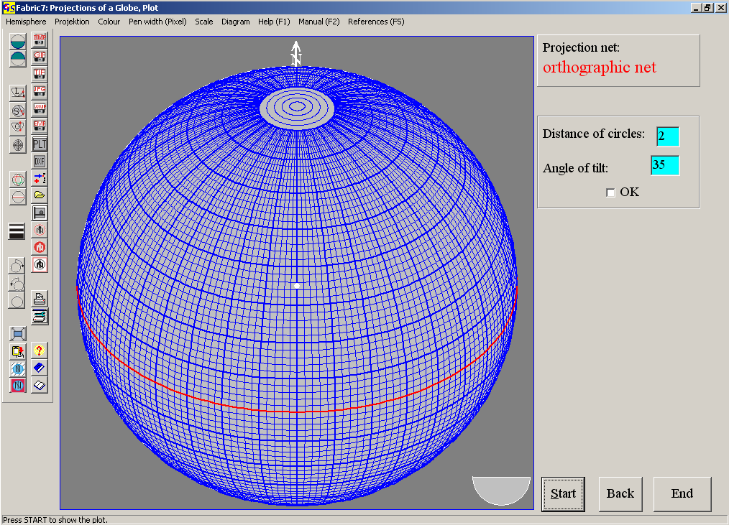
Fig.5

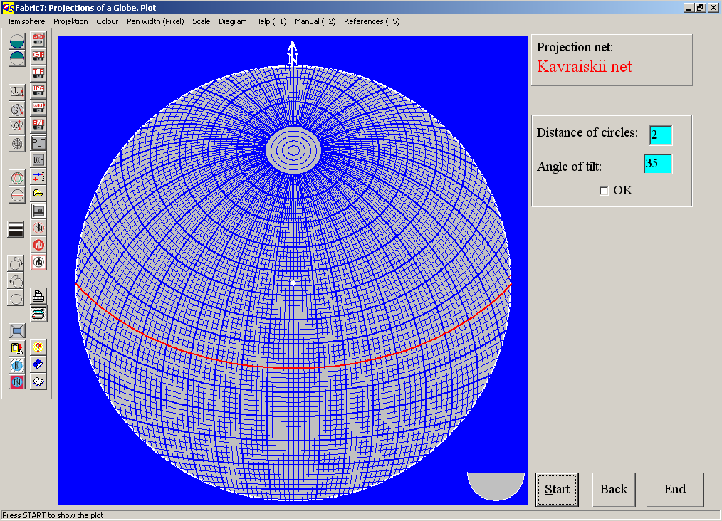
Fig. 6

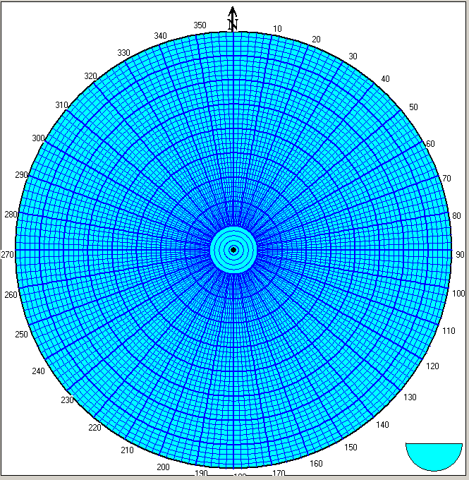Fig. 7

2. Counting grids:
A square grid is produced. On the intersection points counting calottes are plotted (Fig. 8). Projection method, grid distance, size and clour of the calottes, colour of the diagramm, periphery, background and frame can be selected with the corresponding menus
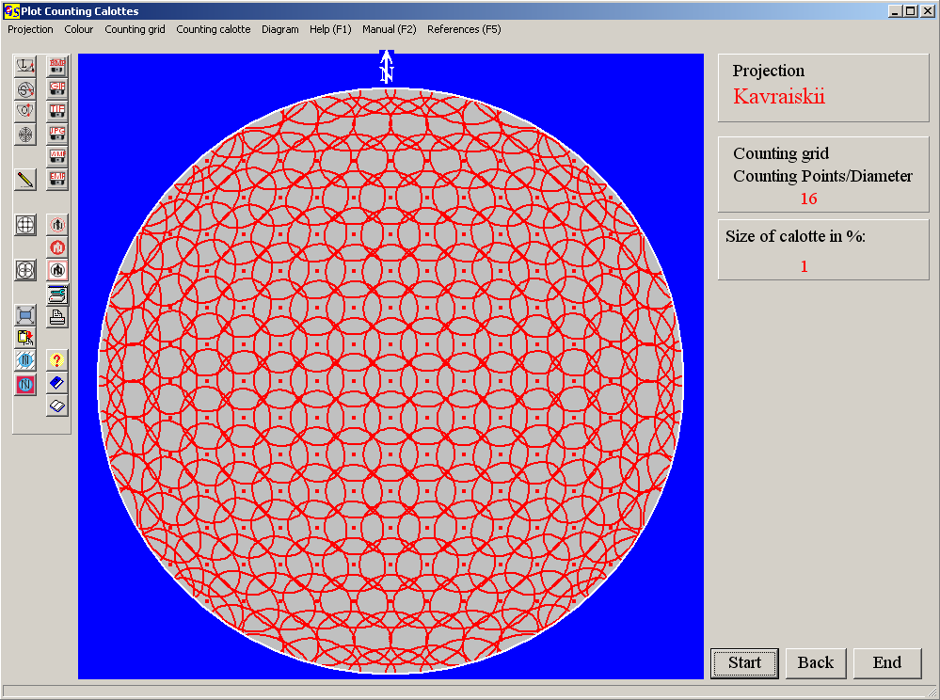Fig. 8.

